Chapter 5: Nazi economic, social and racial policy.

Task 1 pages 48-49 Title: Nazi Policies towards workers.
Key Terms:
Conscription = | Compulsory military services for a certain period of time.
Autobahn = | A federal controlled-access highway system in Germany
German Labour Front (DAF) = | Set up by Robert Ley, The Labour Front acted as the arm of the Nazi Party in employment, ensuring that workers were producing goods for the nation. The Labour Front’s allegiance was to the Reich and not the people it represented.
Strength through Joy (KdF) = | Set up to ensure all aspects of a worker’s non-working time were looked after. Strength Through Joy supervised after-work activities, holidays and leisure time. Strength Through Joy served two main purposes. The first was to ensure that no one had too much time on their hands to get involved in untoward activities against the state.

Overview: https://www.bbc.co.uk/bitesize/guides/zw6s7p3/revision/1
A.) Summarise the 3 headings on p48, MAXIMUM 20 words per summary.
Job Creation schemes:
Invisible unemployment:
Rearmament:
B.) Out of the three summaries, which one defies (disobeys/ignores) the terms of the Treaty of Versailles? Explain how Hitler is breaking the terms.
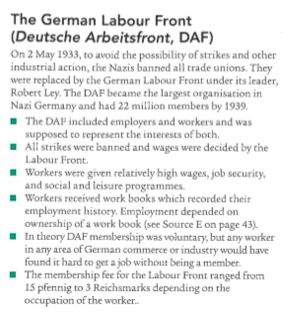
Overview: https://www.bbc.co.uk/bitesize/guides/zw6s7p3/revision/3
Page 49 – See textbook for clearer image.
C.) Which two organisations were set up to control the workforce?
D.) Organise the DAF bullet points into positives and negatives from a German workers perspective.
E.) Does it appear that the German workers benefitted from the DAF scheme?
F.) What was the purpose of the Volkswagen scheme?

G. Practice Question – 8 marks
What was the purpose of Source C?
Use details from the source and your own knowledge and understanding of the historical context to answer the question.
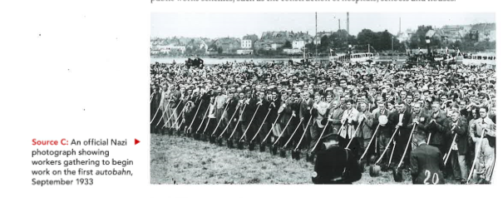
C + A + HC + Q
The content of the source tells me …
The source was produced by… which is important because …
At this time …
The purpose of the source was therefore …
- - - - - - - - - - - - - - - - - - - - - - - - - - - - - - - - - - - - - - - - - - - - - - - - - - - - - - - - - - - - - - - - - - - - - - - - - - - - -
H. Self assessment.
Using 4 different coloured pens or the highlighting tool on word, identify where you have provided information for C + A + HC + Q.
Model example: Purpose Q (NOT linked to the source C above)
C + A + HC + Q
The content of the source tells me that Hitler and Goebbels were trying to control all the German people by making everyone everywhere listen to his broadcast at a certain time as he has important information to share. The source was produced by A German newspaper advertisement which is important because the Nazis have been taking over the newspapers to use it for propaganda so are using it to make it look like it was not written by them and they are just trying to make everyone listen to the radio. At this time the Nazis had just came into power and were still trying to gain support from all of the German public. So by putting themselves everywhere people when then being forced to support them. The purpose of the source was therefore to make the German public to follow and support the Nazis as they were so heavily influenced by the Nazis taken over. The source shows they didn’t really have a choice because ….

Chapter 5: Nazi economic, social and racial policy.
Title: Nazi Policies towards workers.
Task 2 pages 50-51
Strength through Joy (KdF) = | Set up to ensure all aspects of a worker’s non-working time were looked after. Strength Through Joy supervised after-work activities, holidays and leisure time. Strength Through Joy served two main purposes. The first was to ensure that no one had too much time on their hands to get involved in untoward activities against the state.
Trade Unions = | Organisations set up to protect and improve the rights of workers.

Strength through Joy (KdF) This was an organisation set up by the German Labour Front, its sole purpose was to ‘control’ German workers leisure time.
A.) Read the text at the top of page 50 & write a summary of the available activities for German workers. Aim to include the keywords below:
Canary islands | Tours | Cheap | 10 million | Beauty of Work | Working conditions

B.) Why do you think the KdF appealed to German workers?
C.) How did the KdF benefit the overall Nazi regime (system)?
- - - - - - - - - - - - - - - - - - - - - - - - - - - - - - - - - - - - - - - - - - - - - - - - - - - - - - - - - - - - - - - - - - - - - - - - - - - - -

Pages 51-52 Title: The role of Women
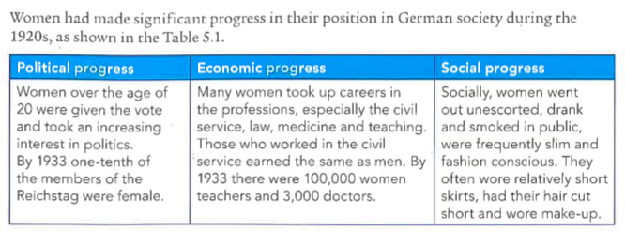
D. Using the above information, create a ‘text to sketch’ image for how women made progress in Germany during the 1920’s.

Model sketch: Political progress
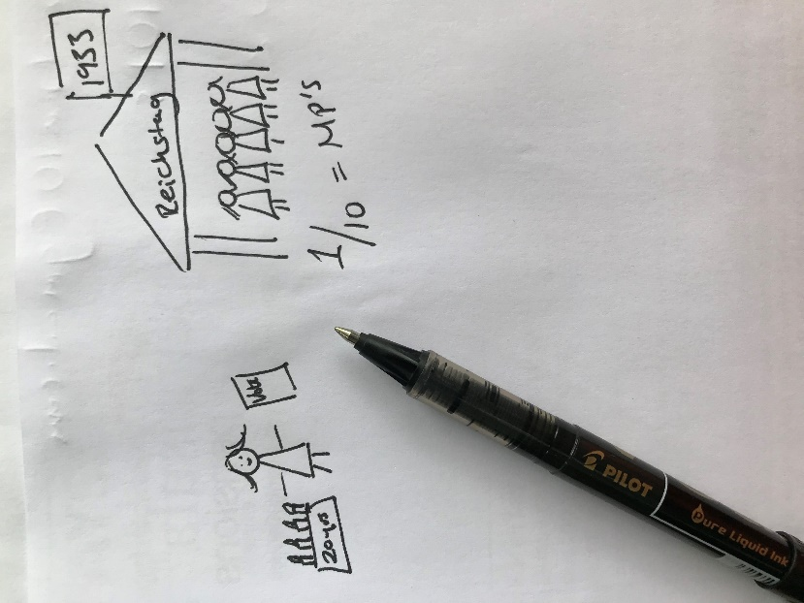
My drawing shows a stick woman holding the ‘vote’ in her hand & an image of a birthday cake indicating she is 20 years old.
The Reichstag building in 1933, the flag represent the year. I have written the statistic of how many women were MP’s (Members of Parliament) at the time.

Please try to create your own for:
Economic progress and Social Progress.

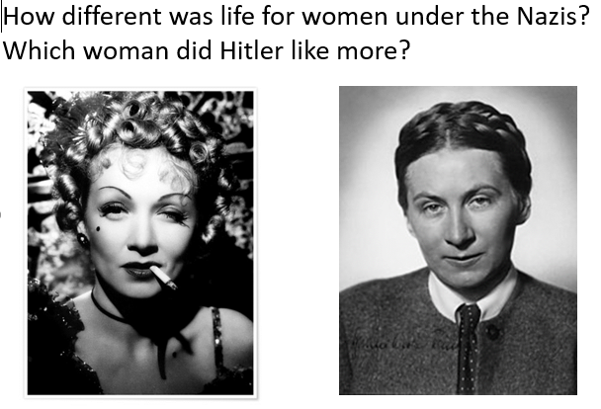
Women in 1920s Germany Women in Nazi Germany

The Nazis had very traditional views of the role of women, which was very different from the position of women in the 1920s.

E.) Copy the table and place the statements in the CORRECT columns, use page 51-52 to help you.
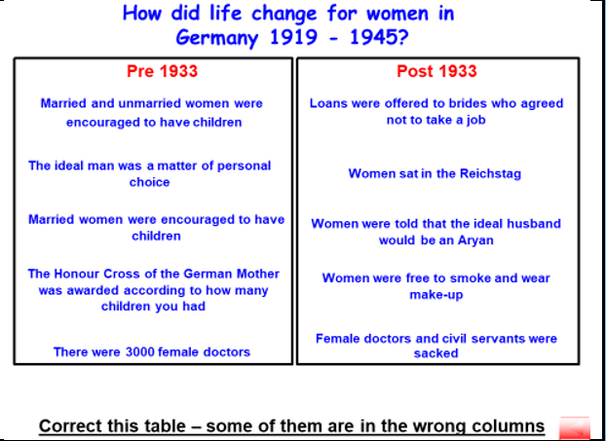

Source I: A Nazi poster of 1937 showing the ideal image of a German Woman.
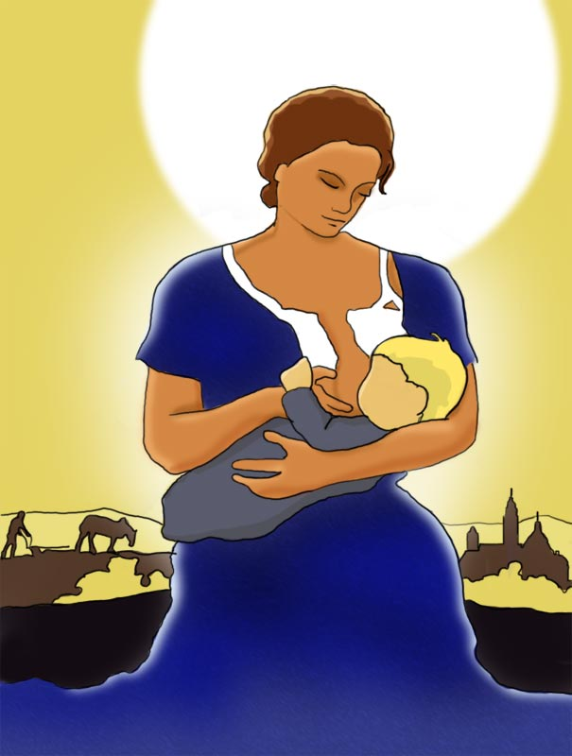
The German translates (on p51) as ‘Support the cause – mother and child’.

F.) What does this propaganda poster tell you about Nazi beliefs concerning the role of women within Germany?
The Nazis have placed a nursing mother in the centre because…
The babies hair is blonde because…
In the background I can see a farmer worker, this represents…
Also I see a Church, this represents…
The Sun is taking up so much of the background because…
This idyllic scene fits in with The Nazi vision of perfect society because…

G.) Google translate the below:
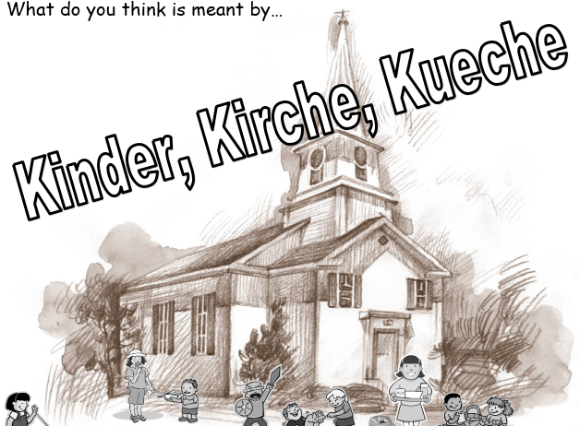
This phrase was often used by the Nazis to describe their vision of what life for women should be like.

Kinder =
Kirche =
Kueche =

H.) Why did the Nazis adopt the three Ks’ to demonstrate their ideal Aryan* Woman?
Aryan* = Nazi term for a non-Jewish German, someone of supposedly ‘pure’ German stock.

Chapter 5: Nazi economic, social and racial policy.
Title: Nazi Policies towards women: Marriage and Family.
Task 3 pages 52-54
Aryan = | Nazi term for a non-Jewish German, someone of supposedly ‘pure’ German stock.
Birth rate = | The number of babies born.
Law for the Encouragement of Marriage = | Gave newlywed couples a loan of 1,000 marks, and allowed them to keep 250 marks for each child they had.
Lebensborn = (Life Springs) | A Nazi programme (meaning Fountain of Life) which aimed to create a strong Aryan 'master race'. It encouraged unmarried mothers and single women to birth children with SS members. The Nazis established several 'birthing homes' where this could take place secretly.
Three Ks’ | Hitler believed women’s lives should revolve around the three 'Ks': Kinder, Küche, Kirche (Children, Kitchen, Church).  The Nazis expected women to stay at home, look after the family and produce children in order to secure the future of the Aryan race.

The Nazis desperately wanted to improve the birth rate to secure Germanys future generations as true Aryans.
A.) Read the bullet point text on page 52 and describe how the Nazis overcame the problem of low birth rates.
- Marriage Laws =
- Loans for families =
- Medals/Mother Cross =
- Divorce =
- Donate a baby =
- Germans Women’s Enterprise =
B.) Overview https://www.bbc.co.uk/bitesize/guides/z2932p3/revision/5
- - - - - - - - - - - - - - - - - - - - - - - - - - - - - - - - - - - - - - - - - - - - - - - - - - - - - - - - - - - -
Women & Work: page 53
C.) Design a mind map to show the expectations of German women in Nazi Germany.
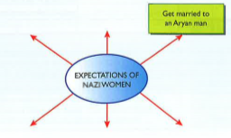
Include, marriage, appearance, employment.

D.) Practice Question.
Do the interpretations support the view that the lives of women worsened under the Nazis? [10]
(C+A+IA+HC+E) x2
J
C = Content
A = Author
IA = Intended Audience
HC = Historical Context
E = Example
J = Judgement
Interpretation 1:
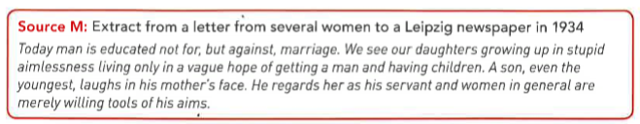
Interpretation 2:
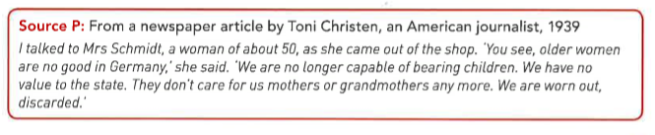
Teacher verbal explanation:
Step 1
https://eggbuckland.sharepoint.com/:u:/g/History/EdY_Y7tG_stFkQi1zr8uDb8BiCdK2do_bTeeFl6KGNqW6Q?e=iVVzm5
Step 2
https://eggbuckland.sharepoint.com/:u:/g/History/Ec9fjpJ2KdlNlBULUwTqDcIBnurQYfs4XIb6D1JduNc9nw?e=8wLzYr

D.) Practice Question.
Do the interpretations support the view that the lives of women worsened under the Nazis? [10]
(C+A+IA+HC+E) x2
J
The first interpretation, Source M supports/does not support the view because….
Its content describes…
It was written by…. in…. this is important because at the time…..
It was intended to be read by….. and convince people to think…….
In addition……….
The Second interpretation, Source P supports/does not support the view because….
Its content talks about…
It was written by…. in…. this is important because at the time…..
It was intended to be read by….. and convince people to think…….
In addition……….

Overall judgement…
E. Self assessment.
Using 6 different coloured pens or the highlighting tool on word, identify where you have provided information for (C+A+IA+HC+E) x2
J

Chapter 5: Nazi economic, social and racial policy.
Title: Nazi Policies towards Education.
Task 4 pages 55-57
Reich = | In German, this has many meanings – state, kingdom, empire. When used by the Nazis it tended to mean ‘empire’ or ‘Germany’.
Aryan = | Nazi term for a non-Jewish German, someone of supposedly ‘pure’ German stock.
Heil Hitler = | To cheer, salute, or greet; welcome. to acclaim; approve enthusiastically to Hitler.
Nazi Teachers’ League | Teachers and university lecturers had to join, which would question their suitability to teach. They were forced to teach a very specific curriculum.
Anti-Semitism = | Hostility toward or discrimination against Jews as a religious or racial group.
Hitler Youth = | German Hitlerjugend, organization set up by Adolf Hitler in 1933 for educating and training male youth in Nazi principles.  The Hitler Youth catered for 10 to 18 year olds. There were separate organisations for boys and girls. The task of the boys section was to prepare the boys for military service. For girls, the organisation prepared them for motherhood.

Overview:
https://www.bbc.co.uk/bitesize/guides/zsdfr82/revision/4
https://www.bbc.co.uk/bitesize/guides/zw6s7p3/revision/5
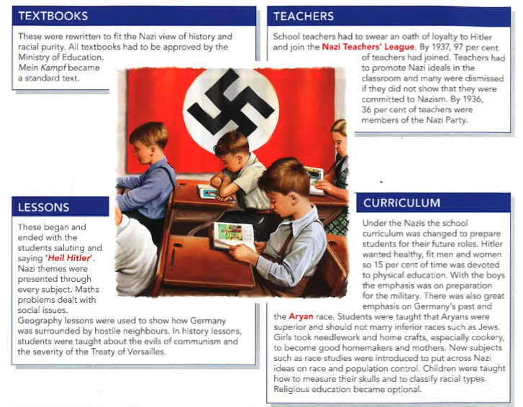
Hitler was well aware of the importance of the young. He wanted to develop an education system that would provide political and military training. The man he chose to run Germany’s schools was Bernhard Rust and under him, German schools were Nazified. The content of lessons also changed. Teachers would have to be greeted at the start of lessons with a Nazi salute. The content of lessons and textbooks was carefully controlled to emphasize Nazi beliefs and values. In particular history and biology lessons gave the Nazi interpretation of the injustices of the Treaty of Versailles, the evils of communism, Jews and betrayal, and Nazi views on racial superiority. To start with, Jewish children were singled out for humiliating treatment in class. The amount of time given to physical education was dramatically increased.
A.) Complete questions 1-4 on page 55 in full sentences.
Sub title: The Hitler Youth Movement
Just like the Strength through Joy (KdF) program, Hitler wanted to control the leisure time of young people as well as their school time.
Overview: https://www.bbc.co.uk/bitesize/clips/zh44d2p

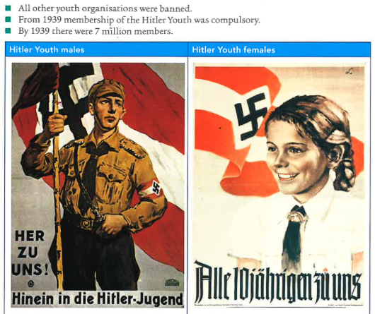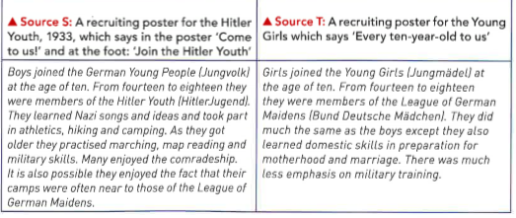

B.) Source S suggests the Hitler Youth movement…
C.) Source T suggests the Hitler Youth movement…

How successful were these policies? Page 57
Although many young Germans joined the Hitler Youth, it was not popular with some of its members.
Here a couple of youth resistant groups who attempted to disrupt the Nazis regime.
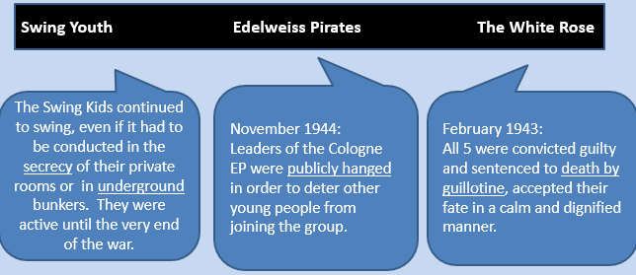
Overview: https://www.bbc.co.uk/bitesize/clips/zwffb9q
C.) How useful are Sources U and V to an historian studying the Hitler You Movement?
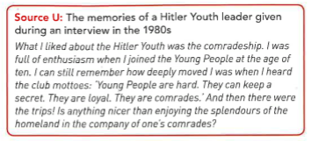
Source U is useful because...
The content tells us about…
It was written by… in …
This means it could be useful because….
However we must also be wary of this source because …
At the time in Germany…
It is less useful because…

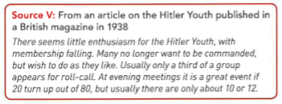
Source V is useful because…
The content tells us about…
It was written by… in …
This means it could be useful because.
However we must also be wary of this source because …
At the time in Germany…
It is less useful because…
Overall the most useful source is… because….

Chapter 5: Nazi economic, social and racial policy.
Title: Nazi Policies towards Jews
Task 5 pages 58-63
Herrenvolk = | Master Race/Aryan
Aryan = | Nazi term for a non-Jewish German, someone of supposedly ‘pure’ German stock.
Untermenschen = | Subhuman, in the Nazis opinion this included Jews and Slavs.
Selective breeding = | Selective breeding is the process by which humans control the breeding of organisms (or Humans in the Nazis case) in order to exhibit or eliminate a particular characteristic.
Anti-Semitism = | Hostility toward or discrimination against Jews as a religious or racial group.
Persecution = | Hostility and ill-treatment, especially because of race or political or religious beliefs; oppression. i.e. mistreat, harass, punish.

Overview:
https://www.bbc.co.uk/bitesize/guides/zw6s7p3/revision/7
https://www.bbc.co.uk/bitesize/guides/zw6s7p3/revision/8
A.) Complete questions 1-2 on page 58 in full sentences.
Anti-Semitism is nothing new sadly and goes back to the Middle Ages.
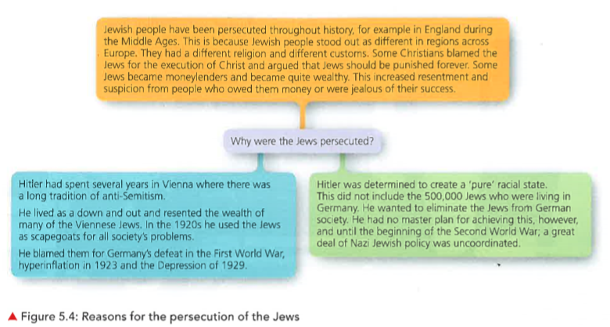
B.) Copy & complete:
There are many reasons why Jews have persecuted for centuries…
Hitler also had his own personal reasons why he was anti-Semitic…
Source BB:
A Nazi cartoon of the early 1930’s. Translated, the title reads ‘Jewish department store octopus’.
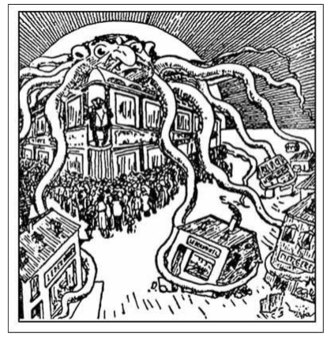
In order to understand this image better we need to add some context.

Teacher verbal explanation:
https://eggbuckland.sharepoint.com/:u:/g/History/EbMaxb6BRKlHk9p6_Ivm6WMB9o_9Exd6vwzLg6JtDHJK6w?e=tTNbKT
C.) Study Source BB. Why was the cartoon published in the early 1930’s? (HINT, Hitler’s leadership)
- - - - - - - - - - - - - - - - - - - - - - - - - - - - - - - - - - - - - - - - - - - - - - - - - - - - - - - - - - - - - - - - - - - - - - - - - - - - -
Anti-Semitism in schools page 60
D.) Skim and scan the text on page 60 and answer the following questions.
i.) How were German children taught about Anti-Semitism?
ii.) Who controlled the schools teaching materials and textbooks?
iii.) In what year were Jewish teachers no longer allowed to give private tuition to German students?
iv.) In what year were Jewish children expelled from German schools?

C.) How useful are Sources DD and EE to an historian studying how education was used to encourage hatred of Jews?
Q+C+E+A+HC x2
J

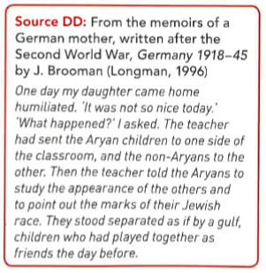
Source DD is useful because...
The content tells us about…
It was written by… in …
This means it could be useful because….
However we must also be wary of this source because …
At the time in Germany…
It is less useful because…

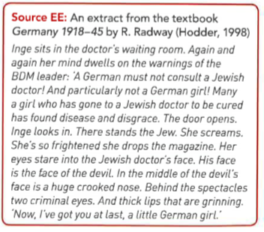
Source EE is useful because...
The content tells us about…
It was written by… in …
This means it could be useful because….
However we must also be wary of this source because …
At the time in Germany…
It is less useful because…
Overall the most useful source is… because….

Chapter 5: Nazi economic, social and racial policy.
Title: Nazi Policies towards Jews
Task 6 pages 58-63
Herrenvolk = | Master Race/Aryan
Aryan = | Nazi term for a non-Jewish German, someone of supposedly ‘pure’ German stock.
Anti-Semitism = | Hostility toward or discrimination against Jews as a religious or racial group.
Persecution = | Hostility and ill-treatment, especially because of race or political or religious beliefs; oppression. i.e. mistreat, harass, punish.
Kristallnacht = | or the Night of Broken Glass. It was an attack Jews carried out by SA paramilitary forces and civilians throughout Nazi Germany on 9–10 November 1938.

A.) Read the text at the top of page 61.
Explain why open discrimination towards the Jews diminished (reduced) during the Berlin Olympics, 1936?
Video for context: https://www.youtube.com/watch?v=gNKlxcqLKcM&list=PL8DC9688AFAEDC4D8&index=20

B.) Complete questions 1 -3 on page 61.

Example: Q1. Go through each box on the flow chart & add to the table below.
Political | Economic | Social
A law excluded Jews from government jobs. | Boycott of shops. | Local councils banned Jews from public spaces such as parks, swimming pools.

- - - - - - - - - - - - - - - - - - - - - - - - - - - - - - - - - - - - - - - - - - - - - - - - - - - - - - - - - - - - - - - - - - - - - - - - - - - - -
Kristallnacht (9 November 1938) and 1939.
This increasingly severe persecution came to a violent climax in November 1938. A Jewish student, Herschel Grynszpan, bitter about the deportation of his parents from Germany marched into the German embassy in Paris and shot dead the first diplomat he saw. The Nazi government seized on the incident as a reason to attack Germany’s Jewish community. The SS and Gestapo organised a wholesale attack on Jewish shops, premises, synagogues and school. At least 7,500 Jewish-owned shops were destroyed and 191 synagogues were burned on 9 November 1938 in an event known as Crystal Night (Kristallnacht). The death toll probably ran into hundreds and 30,000 Jewish men were arrested in the following week and sent to concentration camps.

Overview: https://www.bbc.co.uk/bitesize/clips/zkhhfg8
There was a fierce reaction to Kristallnacht abroad, with many foreign countries and newspapers reacting with horror to the events of that night. The true nature of the Nazis had now been clearly revealed and, ominously, Hitler declared in a speech to the Reichstag in January 1939 that if war broke out it would lead to the annihilation of the Jewish race in Europe.
C.) Practice Question: Q+C+E+A+HC x2
J
How useful are Sources FF and GG to an historian studying the events of Kristallnact?
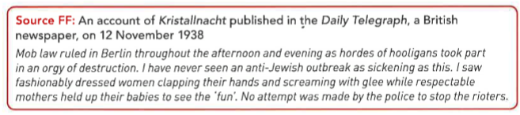
Source FF is useful because...
The content tells us about…
It was written by… in …
This means it could be useful because….
However we must also be wary of this source because …
At the time in Germany…
It is less useful because…
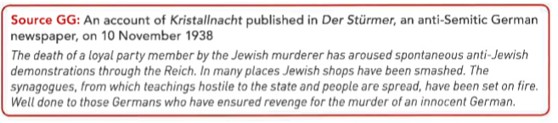
Source FF is useful because...
The content tells us about…
It was written by… in …
This means it could be useful because….
However we must also be wary of this source because …
At the time in Germany…
It is less useful because…
Overall the most useful source is… because….

D.) Self assessment.
Using 6 different coloured pens or the highlighting tool on word, identify where you have provided information for Q+C+E+A+HC x2
J
Modelling example:
Source FF is useful because...
The content tells us about…
It was written by… in …
This means it could be useful because….
However we must also be wary of this source because …
At the time in Germany…
It is less useful because…

Source GG is useful because...
The content tells us about…
It was written by… in …
This means it could be useful because….
However we must also be wary of this source because …
At the time in Germany…
It is less useful because…
Overall the most useful source is… because….

?How many marks do you feel you achieved out of 11marks?

To summarise this final part of this this chapter, use your knowledge and understanding from textbook pages 58 – 63 to answer the following question.

NB= This is a simpler version of the traditional 16 mark question on the Germany exam.

Before you begin, quickly mind map all the problems Jews faced between 1933-39.
E.) Please finish off what I have started.

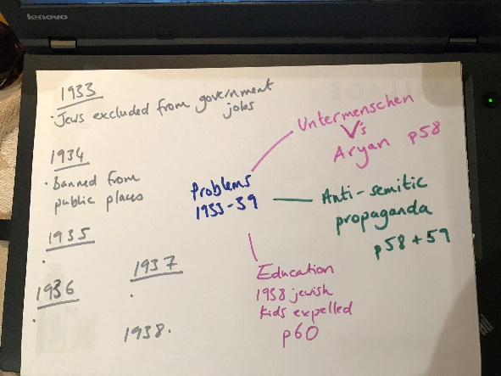

Teacher verbal explanation: https://eggbuckland.sharepoint.com/:u:/g/History/ET8IJkMoIlxMmb7QSd9M8TcBS9u8fK2ulykTEu0S5xy4uw?e=uAvn9j

F.) To what extent do you agree with this view?
“Kristallnacht was the worst problem faced by Jews in Germany in the years 1933-39”.

In some ways this view is accurate because…………….people have this opinion because…………………….
It is accurate because……………………….. Also during in Germany at this time people believed…………...
Kristallnacht was a clear turning point for Jews because…………………………………………………………………...
However, one could argue there were other problems faced by the Jews which were far greater than
Kristallnacht for example……………………………………………………………………………………………………………….……
Historians disagree Kristallnacht was not the worst problem because before Kristallnacht………………..
Overall I agree/disagree with this view/opinion because………………………………………………………………..….

