DICTIONARY SKILLS
Masculine or feminine? Write the French word and (m or f)
1) finger ____________________
2) peach ____________________
3) stress ____________________
4) test ____________________
5) direction ____________________
6) coffee ____________________
7) apple ____________________
8) food ____________________
9) picnic ____________________
10) fly ____________________
11) clock ____________________
12) mouse ____________________
Plurals
13) eye ____________________
14) work ____________________
15) knee ____________________
16) cabbage ____________________
17) newspaper ____________________
Adjectives – masculine and feminine
Masculine Feminine
18) happy ________________ ___________________
19) noisy ________________ ___________________
20) useless ________________ ___________________
21) neat ________________ ___________________
22) new ________________ ___________________
23) little ________________ ___________________

Adjectives - correct meaning
24) The cave was dark and a bat flew out. ___________
25) We arrived at the station late and missed our connection. ____________________
26) The elephant had a very small trunk. ________________
27) I normally apply only two coats of paint. ____________
28) I went to the shop for a hammer and a nail. _____________

Verbs – correct meanings
29) To bother
a) (worry) _____________ b) (disturb) ___________
30) To rest
a) (relax) ______________ b) (lean something) ____________

Conjugated verbs
31) we give = nous donnons
31) he says _____________
32) you want _________________
33) he takes_________________
34) I go out _________________
35) we do _________________
36) they finish _________________
37) you throw _________________
38) they see _________________
39) I sleep _________________
40) we drink __________________
Extn: Can you use the conjugated verbs above to make sentences by adding words you already know (or new ones from the dictionary)?
Eg/ I leave at 8.00 – Je sors à huit heures
______________________________________________________________________________________________________________________________________________________________________________________________________________________________________________________________________________________________________________________________________________________________________________________________________________________________________________________________________________________________________________________________________________________________________________
Dictionary Challenge
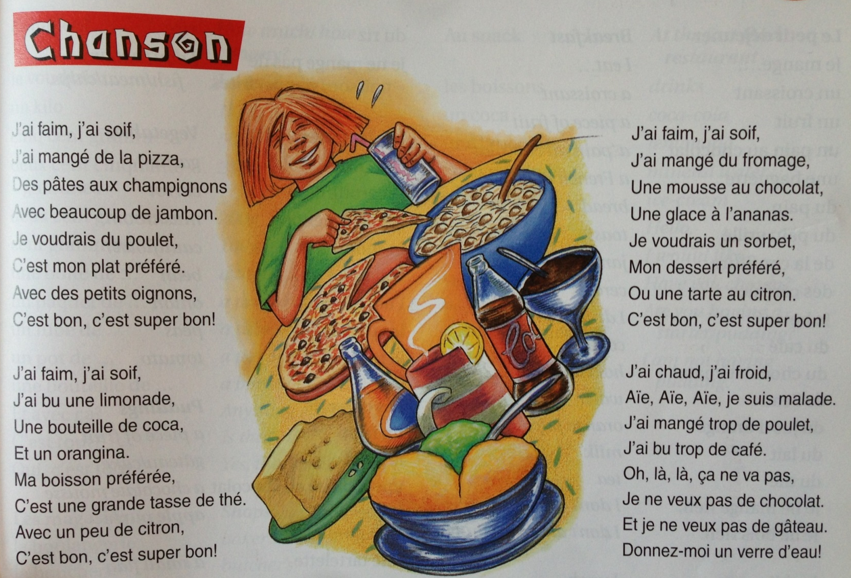
Use the dictionary to find key words for the song above. Annotate the text with the words you find and try to write out the English translation below:

