TASK 1

INSTRUCTIONS

- Read the question carefully.
- Circle the correct letter.
- Answer all questions.

1. | Which cells produce antibodies?
 | a. | T Cells
 | b. | K Cells
 | c. | Z Cells
 | d. | B Cells
12. | What do antibodies do?
 | a. | Neutralise pathogens.
 | b. | Bind to specific antigens.
 | c. | Kill the pathogen.
 | d. | Cause pathogen to multiply.
3. | What is a placebo?
 | a. | A substance that looks like the drug but is a mild version.
 | b. | A substance that looks like the drug but is a high dose.
 | c. | A substance that looks like the drug contains a different medicine.
 | d. | A substance that looks like the drug but does not contain any medicine.
4. | Which one of the following is NOT carried out in preclinical trials?
 | a. | Testing on animals.
 | b. | Double blind testing.
 | c. | Testing on human cells.
 | d. | Testing on human tissues.
5. | Phagocytosis is when…
 | a. | White blood cells release antibodies.
 | b. | White blood cells engulf the pathogen.
 | c. | White blood cells neutralise toxins.
 | d. | White blood cells do nothing.

1 question, 5 sentences, 5 words
GCSE Biology – Health, disease and medicines

TASK 2
INSTRUCTIONS

- For the statement in the task, use either the suggested website or your own text book to write a 5-point summary. In examinations, answers frequently require more than 1 key word for the mark, so aim to include a few key words.
- It is important to stick to 5 sentences. It is the process of selecting the most relevant information and summarising it, that will help you remember it.
- Write concisely and do not elaborate unnecessarily, it is harder to remember and revise facts from a long paragraph.
- Finally, identify 5 key words that you may have difficulty remembering and include a brief definition. You might like to include a clip art style picture to help you remember it.

Example:
QUESTION: | What is the difference between communicable and non-communicable diseases?
Sources: | Website – http://filestore.aqa.org.uk/textbooks/sample/gcse-biology/AQA-8461-OXFORD-SAMPLE.PDF  Interactive -
- Pathogens are microorganisms such as viruses and bacteria that cause infectious diseases in animals and plants.
- They depend on their host to provide the conditions and nutrients that they need to grow and reproduce. They frequently produce toxins that damage tissues and make us feel ill.
- Communicable (infectious) diseases (e.g., tuberculosis and flu) are caused by pathogens such as bacteria and viruses that can be passed from one person to another
- Non-communicable diseases cannot be transmitted from one person to another (e.g., heart disease and arthritis).
- Both communicable and non-communicable diseases are major causes of ill health, but other factors can also affect health.

Pathogen  Disease causing microorganism. |  |  | Communicable  Can be passed on from one person to the next. | Non-communicable  Cannot be passed on to another person. | Virus  Smallest pathogen that invades the cell. | Bacteria  Pathogen that releases toxins into the blood.
QUESTION 4: |  | Describe how viruses and bacteria infect the body and cause disease. Give specific examples.
Sources: |  | Website – http://science.howstuffworks.com/life/cellular-microscopic/virus-human2.htm  Interactive - https://www.my-gcsescience.com/aqa/biology/viral-bacterial-fungal-and-protist-diseases/

TASK 3
Video summaries
GCSE Biology – Health, disease and medicines

Cornell Notes
At A level and University, you will make large amounts of notes, but those notes are only of use if you record them in a sensible way. One system for recording notes is known as the Cornell notes system. This method encourages you to select relevant information, rather than trying to write a transcript of everything said. More importantly, it forces you to spend a few minutes reviewing what you have written, which has been scientifically proven to aid learning and memory retention.
The ideal is to write everything on one page, but some students may prefer to type and others will handwrite their notes. Whichever option you use, remember the aim is to summarise and condense the content with a focus on the objectives that you are trying to learn and understand.

There are three main sections to the Cornell notes:
- Cue/ Objectives – This can be done before or after the lecture. You may have been provided with the objectives or you may need to decide what they were. You may want to make the link to your learning if this is an additional task or lecture you are viewing, such as this video.
- Notes – In this space you record concisely, simply the things you are LESS likely remember - The NEW knowledge.
- Summary – The most important step that is carried out after the lecture or video. This helps to reinforce learning.
Background
The following short videos present two topics that link to your learning. The first video is where Seth Berkley explains how smart advances in vaccine design, production and distribution are bringing us closer than ever to eliminating a host of global threats -- from AIDS to malaria to flu pandemics. The second video hosted by Maryn McKenna discusses how penicillin changed everything. Infections that had previously killed were suddenly quickly curable. Yet as Maryn McKenna shares in this sobering talk, we've squandered the advantages afforded us by that and later antibiotics.
Source article:
Video 1 – HIV and the flu- a vaccine strategy
Ted Ed: https://www.ted.com/talks/seth_berkley_hiv_and_flu_the_vaccine_strategy

Video 2 – What do we do when antibiotics don’t work anymore?
Ted Ed: https://www.ted.com/talks/maryn_mckenna_what_do_we_do_when_antibiotics_don_t_work_any_more

Task:

You need to produce a set of Cornell notes for the video given above.
Use the following objective to guide your note taking, this links to your learning.

- Discuss the importance of vaccine development.
- Discuss how common diseases and simple surgical procedures may, in the future, become ‘high risk’ due to the emergence of antibiotic resistant bacteria.

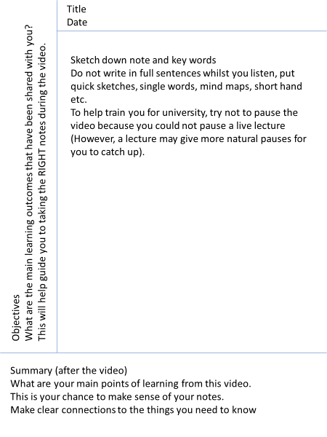

Objectives: | Title:  Date:
Summary:

