Bonjour les enfants,
French work Yr8 1/06-12/06

Well done for keeping on track and doing so well working hard on your French!
Hope you enjoyed your break and you are keeping safe and well.!?
This week and next you will be doing something fun and a bit different!
I hope you like mysteries, I am taking you to a French city close to the border with Switzerland.
LE SORCIER DE VESOUL
A Google StreetView Mystery in French
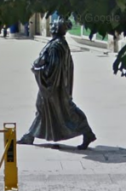

1 Please open the word document “ French-Streetview-Mystery-Vesoul-2020” in SharePoint in the forlder called “Yr8 June week 1-2” .
Follow the instructions from the word document and enjoy!

2 When completed or you fancy doing something alittle different please complete both authetic cultural readings on French cinema and cheeses!

Mlles Moynet, Lourdelet et Grant

