TASK 1

INSTRUCTIONS

- Read the question carefully.
- Circle the correct letter.
- Answer all questions.

1. | In clinical trials, why are healthy volunteers used to test new drugs?
 | a. | To work out the optimum dose to give patients.
 | b. | To see if there are any harmful side effects.
 | c. | To see if the disease can be treated.
 | d. | To determine the efficacy of new drug.
2. | What do antibiotics do in the body? (Pick 2)
 | a. | Attack white blood cells
 | b. | Destroy/slow growth of bacteria
 | c. | Nothing
 | d. | Interfere with cell wall/ contents of pathogens
3. | Which of the follow treats the symptoms of an infection only?
 | a. | Antivirals
 | b. | Antitoxins
 | c. | Aspirin
 | d. | Antibiotics
4. | Which of the following is a non-communicable disease?
 | a. | Measles
 | b. | Cancer
 | c. | Mumps
 | d. | Influenza
5. | What is the name of a tumour that divides slowly and does not spread to other tissues and organs?
 | a. | Benign
 | b. | Cancer
 | c. | Malignant
 | d. | Growth

1 question, 5 sentences, 5 words
GCSE Biology – Health, disease and medicines

TASK 2
INSTRUCTIONS

- For the statement in the task, use either the suggested website or your own text book to write a 5-point summary. In examinations, answers frequently require more than 1 key word for the mark, so aim to include a few key words.
- It is important to stick to 5 sentences. It is the process of selecting the most relevant information and summarising it, that will help you remember it.
- Write concisely and do not elaborate unnecessarily, it is harder to remember and revise facts from a long paragraph.
- Finally, identify 5 key words that you may have difficulty remembering and include a brief definition. You might like to include a clip art style picture to help you remember it.

Example:
QUESTION: | What is the difference between communicable and non-communicable diseases?
Sources: | Website – http://filestore.aqa.org.uk/textbooks/sample/gcse-biology/AQA-8461-OXFORD-SAMPLE.PDF  Interactive -
- Pathogens are microorganisms such as viruses and bacteria that cause infectious diseases in animals and plants.
- They depend on their host to provide the conditions and nutrients that they need to grow and reproduce. They frequently produce toxins that damage tissues and make us feel ill.
- Communicable (infectious) diseases (e.g., tuberculosis and flu) are caused by pathogens such as bacteria and viruses that can be passed from one person to another
- Non-communicable diseases cannot be transmitted from one person to another (e.g., heart disease and arthritis).
- Both communicable and non-communicable diseases are major causes of ill health, but other factors can also affect health.

Pathogen  Disease causing microorganism. |  | Communicable  Can be passed on from one person to the next. | Non-communicable  Cannot be passed on to another person. | Virus  Smallest pathogen that invades the cell. | Bacteria  Pathogen that releases toxins into the blood.
QUESTION 3: | Describe the process of discovery and development of potential new medicines, including preclinical and clinical testing.
Sources: | Website – https://getrevising.co.uk/revision-notes/drug-trials-source-bitesize  Interactive - http://www.bbc.co.uk/education/clips/z6xcd2p

TASK 3
Scientific Posters
GCSE Biology – Health, disease and medicines

INSTRUCTIONS

Scientific Posters
Scientists communicate research findings in three main ways. Primarily, they write journal articles much like an experiment write up. These are very concise, appraise the current literature on the problem and present findings. Scientists then share findings at conferences through talks and scientific posters. During a science degree, you would practise all three of these skills.

Scientific posters are a fine balance between being graphically interesting and attracting attention and sharing just the right amount of text to convey a detailed scientific message. They are more detailed than a talk and less detailed than a paper.
Use this information to help structure your poster – www.tiny.cc/posterskills (that’s Poster Skills not Posters Kill!) More detailed guidance is available at: www.tiny.cc/posterskills2

Creating your poster
It is easiest to create a poster in PowerPoint; however, you need to add custom text boxes rather than using the standard templates.
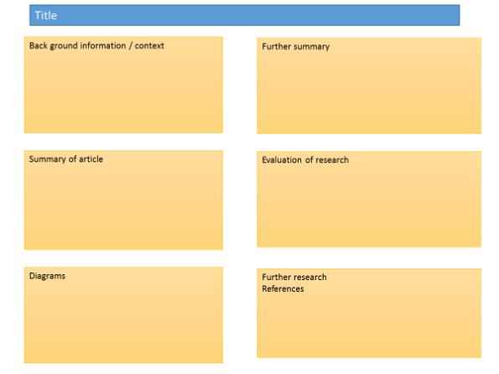
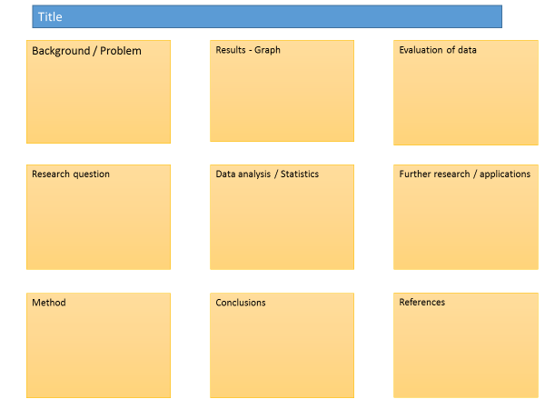

Posters need to be eye catching, but readable from a distance. If you use PowerPoint, start with a 4:3 slide (for easier printing, it can then be printed on A3) and use a 14-16 pt font. The first box could be larger to draw people in. You can use a background image, but pick a simple one that is of high quality. Select text box fill and select change the transparency to maintain the contrast and partially show the picture.
You can experiment with different layouts and you should include images. Avoid a chaotic layout, posters are read from top left column downwards.
Remember to include the authors and references.
Finally, look at the examples given on the University of Texas website which also offers an evaluation of each www.tinyurl.com/postereg

Non - communicable diseases

Background
Most pathogens have to get inside our body to spread infection. Once they are inside, the body provides ideal living conditions, including plenty of food, water and warmth. Standing in their way is our body's immune system - the body's coordinated response to the invading pathogens.

Source articles:
http://www.bbc.co.uk/schools/gcsebitesize/science/21c_pre_2011/disease/diseaseresistancerev2.shtml
https://www.khanacademy.org/test-prep/mcat/cells/transport-across-a-cell-membrane/a/phagocytosis
https://www.thoughtco.com/antibodies-373557
https://revisionworld.com/gcse-revision/biology/human-body/immunisation-vacination
http://www.who.int/mediacentre/factsheets/antibiotic-resistance/en/

Use other sources as necessary.

Task:
Produce a scientific poster on the causes communicable diseases, the immune systems response to infection and the treatment of disease.

Recall | State the non-specific defence systems of the human body against pathogens.
Describe | Describe and explain the role of the immune system in the defence against disease.
Compare | Compare the actions of the body’s immune system when a pathogen enters the body. You should include phagocytosis, antibody production and antitoxin production.
Evaluate | Evaluate the overuse of antibiotics.

