Year 8 English Remote Learning Booklet
Poetry Through Time: Week 1

In this unit, you will study poetry from different periods of time.
This is an important unit as it will help you to develop and understanding of the history of poetry and how it has developed over time.
It will also give you a solid foundation of knowledge to help you study poetry next year, and in your GCSEs.

The booklet will follow our lesson template of:
- LST
- Teacher instruction
- Deliberate Practice
- Learning Review

There are answers to LSTs and other activities at the end of the document, so please green pen/mark those answers yourselves.
You do not need to send any of this work to your teacher. There is one piece of Deliberate Practice every two weeks that you must send your teacher to get feedback on. This will be signposted for you.
Please read the documents carefully. They should take you through all of the knowledge that you need. If you are stuck, make sure you have read everything carefully.
And remember:
When quarantine because of the Plague, it is belived that Shakespeare wrote King Lear.

No pressure!
Lesson 1
Vocabulary for today:
Hallowed= holy, blessed, sacred
Big Question
- What is ‘Old English’ poetry?

Low Stakes Test

- What is a poem?
- What is a stanza?
- What is rhyme?
- What is alliteration?
- A character’s hamartia is their fatal...
- Hubris is having too much…
- What is a soliloquy?
- Who were the Anglo-Saxons?

Teacher Instruction

- During the 5th century, Germanic tribes people known as Angles, Saxons and Jutes began to settle in the British Isles.
- The Anglo-Saxon period lasted for 600 years and, in that time, the language, culture and politics of the British Isles were transformed.
- Anglo Saxon dialect words form the basis of the language we now call Old English, and approximately one third of Anglo-Saxon vocabulary still survives into modern English.
- Around 25-40% of you will have Anglo-Saxon heritage/DNA
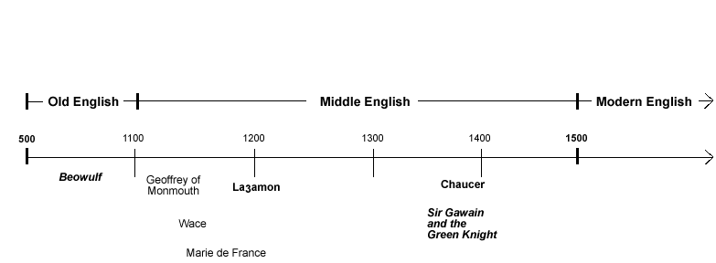

We are going to read 4 different versions of ‘The Lord’s Prayer’.
- You will probably be familiar with the most modern version: English Standard Version 2001
Our Father in heaven, hallowed be your name.
Your kingdom come, your will be done, on earth as it is in heaven.
Give us this day our daily bread, and forgive us our debts, as we also have forgiven our debtors.
And lead us not into temptation, but deliver us from evil.

- This next version is the ‘King James Bible’ version 1611
Oure fadir that art in heunes,
Halwid be thi name
Thy kingdom cumme to;
Be thi willle don as in heuen as in erthe;
Gif to vs this day oure bread ouer other substaunce;
And for geue to vs oure dettis as we for geue to oure detours;
And leede vs nat in to temptacioun;
But delyuere vs fro yuel .
Amen

- 1382 Middle English
Oure fadir that art in heuenes,
halewid be thi name;
thi kyngdoom come to;
be thi wille don, in erthe as in heuene.
Yyue to vs this dai oure breed ouer othir substaunce,
and foryyue to vs oure dettis, as we foryyuen to oure dettouris;
and lede vs not in to temptacioun, but delyuere vs fro yuel. Amen.

- 995 Old English
Fæder ure þu þe eart on heofonum;
Si þin nama gehalgod
to becume þin rice
gewurþe ðin willa
on eorðan swa swa on heofonum.
urne gedæghwamlican hlaf syle us todæg
and forgyf us ure gyltas
swa swa we forgyfað urum gyltendum
and ne gelæd þu us on costnunge
ac alys us of yfele soþlice (note: the old english "þ" is pronounced "th")
Deliberate Practice

Modern | 995 | 1382 | 1611
Father | Fæder
Earth
Heaven
Hallowed
Forgive
Trespasses
Evil
Kingdom |  | kyngdoom
Lead
Find each modern word in ‘The Lord’s Prayer’ and write out the older version.

Learning Review

Can you see the similarities/differences between ‘Old English’ words and their modern versions?
Write a sentence explaining both.
The similarities between the words are…
The differences between the words are…

These are your own opinions, so please don’t worry about getting them wrong/checking them. _

Lesson 2
Vocabulary for today:
Manuscript= document, copy, script
Big Question
- Who are ‘Beowulf’ and ‘Grendel’?

Low Stakes Test

- What is ‘Old English’?
- Can you remember any Old English spellings of ‘father’?
- Where did the Anglo-Saxons move to Britain from?
- Roughly what percentage of modern day Brits have Anglo-Saxon roots/DNA?
- What is a verb?
- What is a noun?
- What is alliteration?
- What do you associate with a ‘beast’?
Teacher Instruction

Beowulf is the most important work of medieval literature that exists in Britain. It is approximately 1000 years old and written in Old English.
This epic poem would have been sung and recited, not written down until later.
We only have one surviving manuscript copy, that was almost destroyed in a fire in London in the 1700s. You can see the manuscript (and its burn marks) in the British Library today.
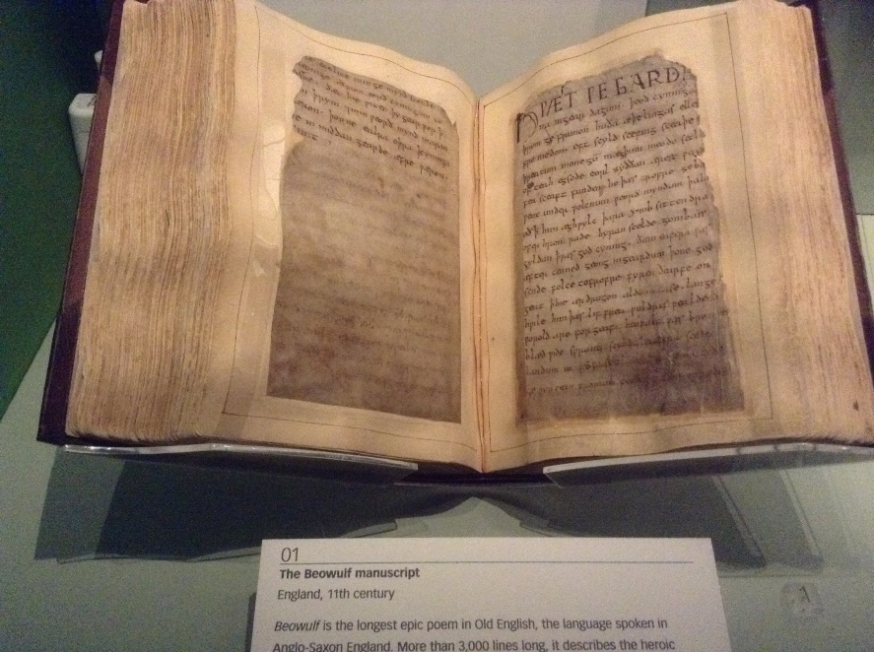

Watch this video on Youtube before having a go at the multiple choice quiz below:
https://www.youtube.com/watch?v=qrm3PJjD7gU
If you cannot open the link, search ‘Beowulf summary and analysis’ on YouTube and click on the first link.
Be careful using the subtitles as they translate by audio and are not entirely accurate! There was nobody called Brenda in Beowulf!

Knowledge Check: Beowulf
- Scholars believe that ‘Beowulf’ was written in:  - The 5th century  - The 8th century  - The 10th century | - What helps to set up a rhythm in the poem?  - Metaphor  - Simile  - Alliteration | - The story takes place in which region?  - Scandinavia  - America  - Asia
- Who was the King of the Danes?  - King James  - Beowulf  - Hrothgar  - How does Beowulf kill Grendel?  - He chops off his head  - He rips off his arm  - He drowns him | - Who attacks the King’s land?  - Beowulf  - Grendel  - The Devil  - How long Beowulf king before the dragon was tormented his land?  - 30 years  - 40 years  - 50 years | - Why did Beowulf want to repay the King?  - Because the king gave him money  - Because the king saved his father  - Because the king gave him land  - How did Beowulf die  - He was burnt by the dragon  - He was poisoned by the dragon  - He was eaten by the dragon

Next, we will read a translated extract from the poem. In this extract, we learn more about the beast, Grendel, and how Beowulf defeated him.
When the feast was over, it was bedtime for the brave
Beowulf. He laid in bed awake, waiting for Grendel to strike.
Grendel stormed through the stone wall, grabbed
a startled soldier with his cruel claws and bit him to the bone.
The monster moved toward Beowulf, and lifted him
out of bed.
But before the beast could open its mouth,
Beowulf put Grendel in an arm lock no man or beast
had ever witnessed, and the monster let out a horrible howl.
The two tumbled about the hall until the sound of the scream
from the loser lifted everyone out of their beds. The monster
had been manacled from a man stronger than him,
and the beast ran recklessly back to his den to die.
Grendel’s arm was torn off by Beowulf’s grasp and
he could not live much longer. Beowulf picked the arm off
the floor, evidence of the fight, and stood among his men victorious.
The next day word got around that the beast had been beaten
by Beowulf. The damaged wall in the hall was repaired,
and Hrothgar gave Beowulf gifts for his courage.
A victory feast was served for supper, and everyone
was the happiest they’d been since Grendel started
running his raids. That night as they settled in for sleep,
it felt great to not worry about Grendel again.
Beowulf went to bed elsewhere. But as soon as
everyone was asleep and silence swept the night,
a second terror lurked in the moonlight.

Deliberate Practice: I Do, We Do, You Do

We are going to look at some quotations that describe Grendel and ‘explode’ them, looking at inference and analysis.
I DO
Copy out this quotation and ‘explode’ it.
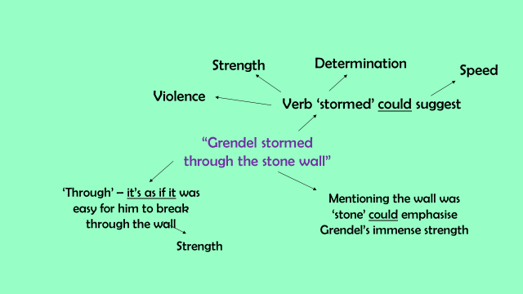
Notice the use of the underlined ‘tentative language’ that helps to open up different interpretations.
We Do
Now, copy this quotation out and annotate it, filling in the gaps with your interpretations.
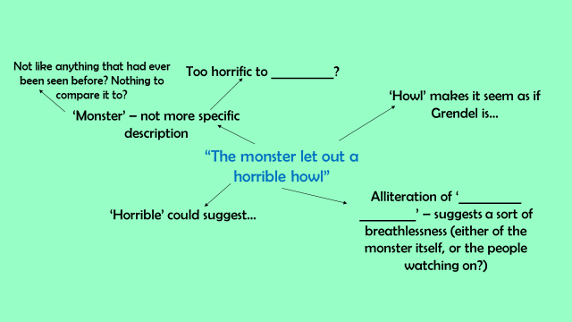
You Do
Now, have a go at exploding the quotations below on your own.
Remember to use tentative language to open up your interpretations.

“The beast ran recklessly back to his den”

“grabbed a startled soldier with his cruel claws”

If you are really stuck, there is some help at the end of this document, but please only look at it if you are completely stuck.
Learning Review

Pick a word that you think best describes Grendel and explain why.

I think the word, ‘_________________’ best describes Grendel because….

Lesson 3
Big Question
- What are ‘The Canterbury Tales’?
Low Stakes Test
- What was the King called in ‘Beowulf’?
- What was the monster called?
- How did Beowulf kill the monster?
- How did Beowulf die?
- What is a verb?
- What is a metaphor?
- What is a simile?
- What is ‘social class’?
Teacher Instruction

Chaucer
Chaucer is best known as the writer of The Canterbury Tales, which is a collection of stories told by fictional pilgrims (a person on a journey to a religious place) on the road to visit the shrine to St Thomas Becket at the cathedral at Canterbury (in Kent); these tales would help to shape English literature. He died before he could finish the Tales.
‘The Canterbury Tales’
- On an April day, a group of English pilgrims meet outside the Tabard Inn and are joined by the innkeeper, just outside London. They set out on a pilgrimage from London to Canterbury to pay their respects to the tomb of Saint Thomas Becket at Canterbury Cathedral.
- The group is described in detail, with characters from all classes, upper and lower, represented. Religious characters, such as a monk, travel alongside a shipman, miller, carpenter and a knight, among others.
- Harry Bailey, the innkeeper, suggests a game where they all tell stories to each other along the way. The pilgrims agree to tell four stories each, two on the way to Canterbury, and two on the way back. The person who tells the best story, as determined by the host, will have his supper paid for by the rest of the group.
- Each person tells a story that reflects their social position, and some tell stories which are intended to make fun of others in the group.
- No winner is chosen by the host in the end, and not all of the pilgrims have told their tales by the time the story ends.
- The Canterbury Tales showed an England we can recognise today. They showed what life in a town was like.
Chaucer drew on real life for his cast of pilgrims. England was going through enormous changes!
Learning Check:
1. What town in Kent are the characters travelling to?
2. Whose shrine are the characters travelling to?
3. What is the name of the innkeeper?
4. Name one of the jobs one of the characters does (apart from the innkeeper!)
5. What is the prize for the competition?
6. How many stories do the characters agree to tell each?
7. Who wins the prize?
8. What is a pilgrim?
9. In which month do the characters make their journey?
10. What is the name of the Inn from where the characters start their journey?

Check answers by looking at the end of the document.

Next, we will read the prologue of ‘The Canterbury Tales’. The modern translation is included.

Bifil it in that seson on a day,
In Southwerk at the Tabard as I lay
Redy to wenden on my pilgrimage
To Caunterbury with ful devout corage,
At nyght was come into that hostelrye
Wel nyne and twenty in a compaignye
Of sundry folk, by aventure yfalle
In felaweship, and pilgrims were they alle,
That toward Caunterbury wolden ryde.
The chambers and the stables were wyde,
And wel we weren esed ate beste.
And shortly, whan the sonne was to reste,
So hadde I spoken with hem evrichon
That I was of hir felaweship anon,
And made forward erly for to ryse,
To take oure wey ther as I yow devise.
But nathelees, whil I have tyme and space,
Er that I ferther in this tale pace,
Me thynketh it accourdaunt to resoun
To telle yow alle the condicioun
Of ech of hem, so as it semed me,
And whiche they weren, and of what degree,
And eek in what array that they were inne;
And at a knyght than wol I first bigynne
It happened at this season, that one day
In Southwark at the Tabard where I stayed
Ready to set out on my pilgrimage
To Canterbury, and pay devout homage,
There came at nightfall to the hostelry
Some nine-and-twenty in a company,
Folk of all kinds, met in accidental
Companionship, for they were pilgrims all;
It was to Canterbury that they rode.
The bedrooms and the stables were good-sized,
The comforts offered us were of the best.
And by the time the sun had gone to rest
I’d talked with everyone, and soon became
One of their company, and promised them
To rise at dawn next day to take the road
For the journey I am telling you about.
But, before I go further with this tale,
And while I can, it seems reasonable
That I should let you have a full description
Of each of them, their sort and condition,
At any rate as they appeared to me;
Tell who they were, their status and profession,
What they looked like, what kind of clothes they dressed in;
And with a knight, then, I shall first begin.

Deliberate Practice

- Were there any differences between the original and the modern version of the prologue?
- What is the story that is being told, so far?
- What information are we given?
- Who do you suppose the narrator is?
- What social class does this narrator belong to? How do you know?

Learning Review:
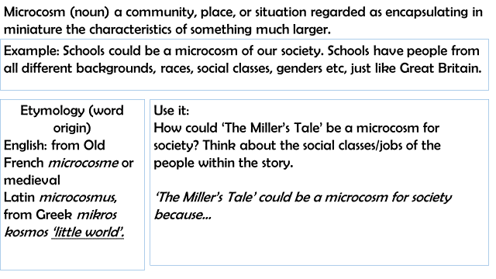

Lesson 1 Answers:
LST:
- What is a poem?
A piece of writing in which the expression of feelings and ideas.
- What is a stanza?
A verse in a poem.
- What is rhyme?
Similar sounds at the end of words, usually used at the end of lines in poetry.
- What is alliteration?
The repetition of sounds/letters at the beginning of closely connected words.
- A character’s hamartia is their fatal flaw.
- Hubris is having too much pride.
- What is a soliloquy?
When a character in a play speaks their thoughts aloud.
- Who were the Anglo-Saxons?
The Anglo-Saxons were a cultural group who inhabited Great Britain from the 5th century that moved from mainland Europe.

Lesson 2 Answers
LST:
- What is ‘Old English’?
An early form of English with Anglo-Saxon roots.
- Can you remember any Old English spellings of ‘father’?
Fadir, fæder
- Where did the Anglo-Saxons move to Britain from?
Europe
- Roughly what percentage of modern day Brits have Anglo-Saxon roots/DNA?
25-40%
- What is a verb?
A word for an action, state or occurrence.
- What is a noun?
A word for a person, place or thing.
- What is alliteration?
Repetition of similar sounds at the beginning of words.
- What do you associate with a ‘beast’?
Violent, uncontrolled, unpleasant

Beowulf quiz answers: B, C, A, C, B, B, B, C, B
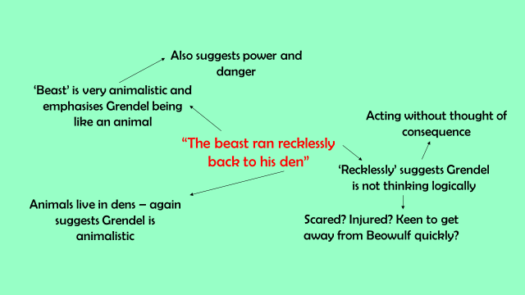

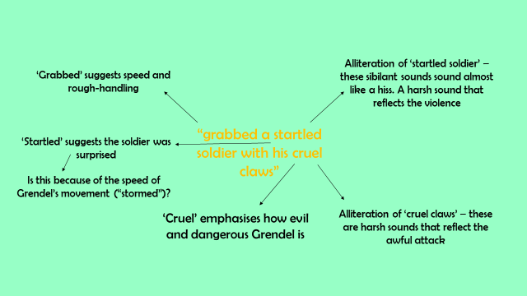

Lesson 3 Answers:
LST
- What was the King called in ‘Beowulf’?
Hrothgar
- What was the monster called?
Grendel
- How did Beowulf kill the monster?
By ripping off its arm.
- How did Beowulf die?
By the dragon’s poisonous teeth.
- What is a verb?
A word for an action, state or occurrence.
- What is a metaphor?
Describing something by comparing it directly with something else.
- What is a simile?
Describing something by comparing it with something else, using ‘like’ or ‘as’.
- What is ‘social class’?
The division of people in a society by their social or economic status.

Canterbury Tales Learning Check
1. What town in Kent are the characters travelling to?
Canterbury
2. Whose shrine are the characters travelling to?
Thomas Becket
3. What is the name of the innkeeper?
Harry Bailey
4. Name one of the jobs one of the characters does (apart from the innkeeper!)
Monk, shipman, miller, carpenter, knight.
5. What is the prize for the competition?
A free supper!
6. How many stories do the characters agree to tell each?
4 each – 2 on the way to Canterbury, and 2 on the way home.
7. Who wins the prize?
No one!
8. What is a pilgrim?
Someone who makes a journey to a religious place.
9. In which month do the characters make their journey?
April
10. What is the name of the Inn from where the characters start their journey?
Tabard Inn

