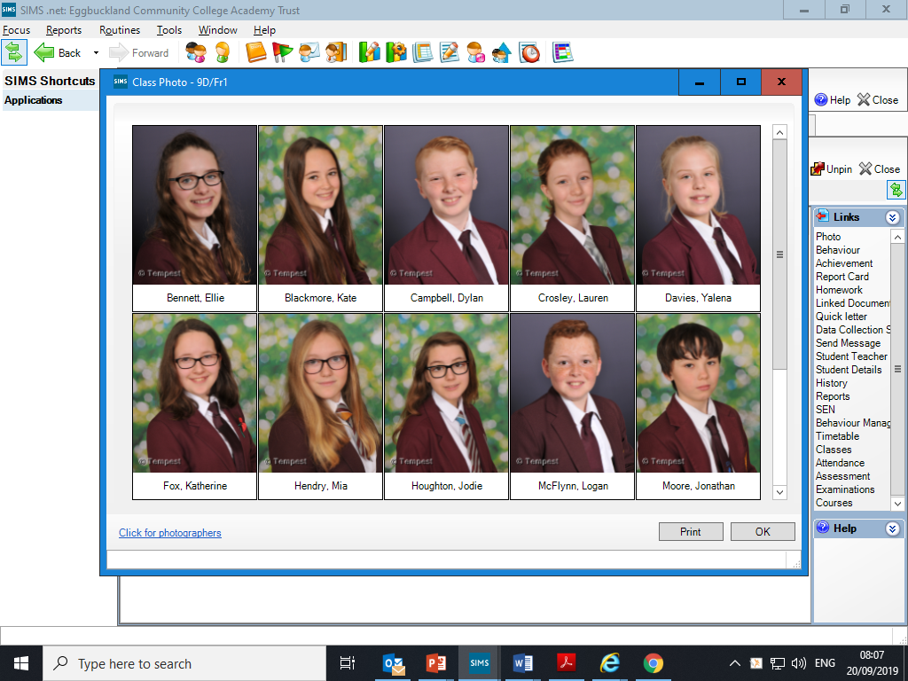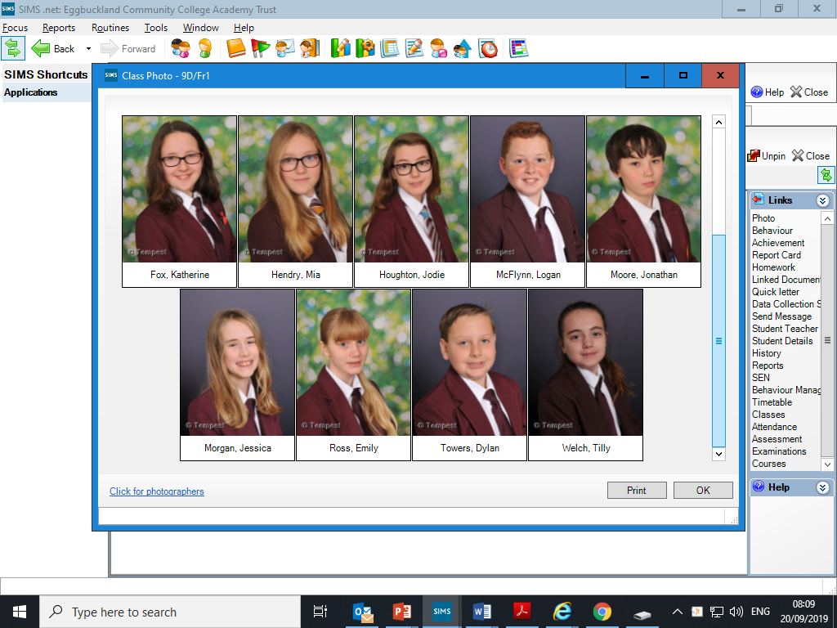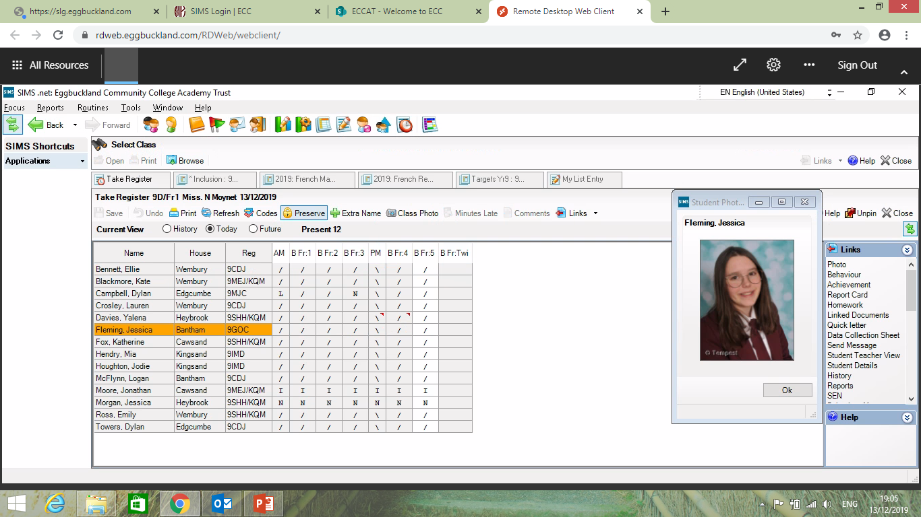

**Bonjour les enfants,**



**9D1 July last weeks French work + summer Hols fun**

**Well done for keeping on track and doing so well working hard on your French in the last 4 months!**

**End of year vocab and grammar retrieval this week!**

**Bonne chance and remember to copy any new words in your ex books ☺**

**1 Open word document “recap Module 1+3”** . Decide whether you’d like to try higher or foundation. If you are predicted a Grade 5 or higher you’ll need to try higher please. I have made them similar anyway so you might as well.

2. During the summer if you want to keep your French “ alive” keep going with Duolingo App, going through your books making flashcards and/ or have a look at the ppt called “ French summer tasks “ and or “ The Great French Language Challenge” to have fun with varied activities.



Your last idiom of the year! “ Holidays are the foot”: holidays are fabulous!