French revision work
MATCH THE FOLLOWING PHRASES AND LEARN THEM;
Bonjour  Au revoir  Comment t’appelles-tu ?  Je m’appelle...  Ca va ?  Tres bien  Comme-ci comme-ca  Ca va mal  Levez-vous  Asseyez-vous  Levez la main  Ecoutez  Lisez  Regardez  Ecrivez | So-so  Very well  Listen  Stand up  Look  Hello  Goodbye  Hand up  Read  How are you?  Write  What’s your name?  Not so good  My name is..  Sit down

/14

*EXTRA !-ADD THE CORRECT ACCENTS TO THE FRENCH FOR;
-HOW ARE YOU?-ÇA VA?
-WRITE-
-VERY WELL-
-LISTEN-
-SO-SO-

HOMEWORK 2
WRITE IN THESE NUMBERS…AND LEARN THEM OFF BY HEART.
UN |  | NEUF
DEUX |  | DIX
TROIS | THREE/3 | ONZE
QUATRE |  | DOUZE
CINQ |  | TREIZE
SIX |  | QUATORZE
SEPT |  | QUINZE
HUIT |  | SEIZE

DIX-SEPT |  | VINGT-CINQ
DIX-HUIT |  | VINGT-SIX
DIX-NEUF |  | VINGT-SEPT
VINGT |  | VINGT-HUIT
VINGT ET UN |  | VINGT-NEUF
VINGT DEUX |  | TRENTE
VINGT-TROIS |  | TRENTE ET UN
VINGT-QUATRE
/30
*EXTRA!-MAKE UP 10 SUMS IN FRENCH!
HOMEWORK 3
FILL IN THE GAPS..
French | English
Le 3 janvier
 | *The 14th of february
1e 10 mars
*Le premier avril
 | The 13th of may
Le 22 juin
 | *The 14th of july
 | The 6th of august
Le 29 septembre
 | The 31st of october
Le 5 novembre
 | *The 25th of december
/12
*EXTRA!-FIND OUT WHAT THE SPECIAL DAYS * ARE IN FRENCH AND HOW THEY ARE CELEBRATED…

HOMEWORK 4
TRANSLATE THIS CONVERSATION INTO ENGLISH,PRACTICE AND LEARN IT!
A.Bonjour comment t’appelles-tu?
B.Je m’appelle Clare et toi?
A.Jean-Paul
B.Ca va ?
A.Tres bien merci et toi?
B. comme-ci,comme-ca
A.Quelle est la date de ton anniversaire?
B. le 8 mars et toi?
A.le 5 juin
B.Quel age as-tu?
A.J’ai douze ans et toi?
B.Douze aussi
B.Au revoir
A.Salut

*EXTRA-rewrite the conversation,changing the names,ages and birthdays…
HOMEWORK 5
LABEL THE FAMILY MEMBERS..
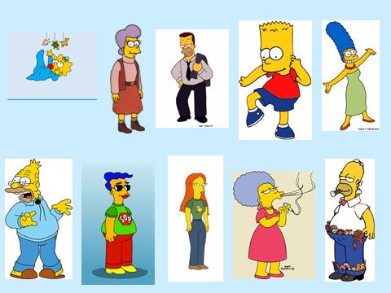
/10
LE PERE LE FRERE LA MERE LA SOEUR
LE BÉBÉ L’ONCLE LA TANTE LE GRAND-PERE LE COUSIN
LA COUSINE

*EXTRA-WRITE 4 SENTENCES ABOUT YOUR FAMILY…
EXEMPLE-..Mon frère s’appelle James
-
-
-
-

HOMEWORK 6
UNSCRAMBLE THESE SENTENCES..
Exemple;
Ma /Jean/s’appelle/grande-mere=Ma grande-mere s’appelle Jean
- onze/j’ai/ans=
- tante/Louise/s’appelle/ma=
- J’ai/souers/trois=
- Pere/mon/trente/a/ans=
- Tu/frères/as/souers/des/ou = /5

*EXTRA-MAKE UP 5 OF YOUR OWN…
-
-
-
-
-
HOMEWORK 6
READ THE SENTENCES AND NUMBER THE ANIMALS CORRECTLY..

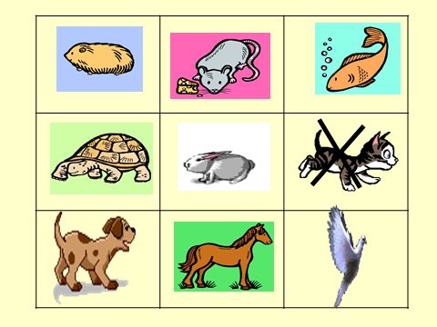
1.J’ai un lapin gris
2.J’ai un petit chien
3.j’ai une grande tortue
4.j’ai un poisson rouge
5.je n’ai pas de chat
6.j’ai un pony
7.j’ai un cochon d’inde
8.elle a une souris
9.il a un oiseau

/9

*EXTRA-TRANSLATE THE 9 SENTENCES INTO ENGLISH
-
-
-
-
-
-
-
-
-

HOMEWORK 7
JE M’APPELLE LUCIE….JADORE LES ANIMAUX.J’AI DEUX CHATS NOIRS,UN CHIEN MARRON,TROIS LAPINS BLANCS ET UN PONEY BRUN ! JE N’AI PAS DE SERPENT PARCE QUE JE DÉTESTE LES SERPENTS MAIS J’ADORE MON PONEY PARCE QUE C’EST AMUSANT !

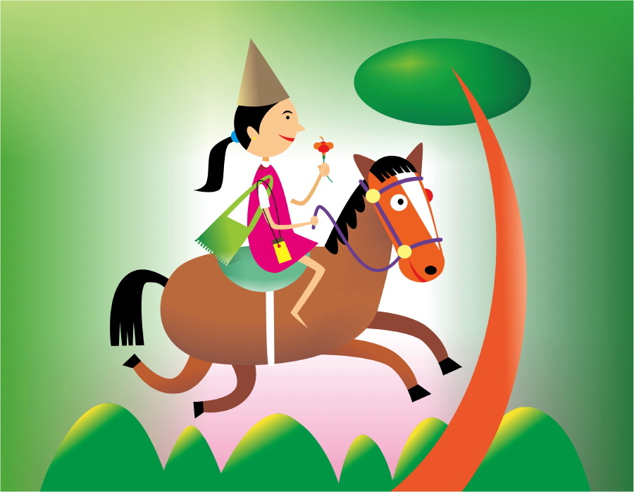
ANSWER TRUE OR FALSE
1.HER NAME IS CLAIRE
2.SHE HAS 3 CATS
3.HER DOG IS BROWN
4.SHE LOVES SNAKES
5.SHE THINKS HER PONEY IS FUNNY

/5
*EXTRA-WRITE THE CORRECT SENTENCES IN ENGLISH OR FRENCH!
-
-
-
-
-
HOMEWORK 8
WRITE 6 FACTS IN ENGLISH ABOUT HARRY POTTER..
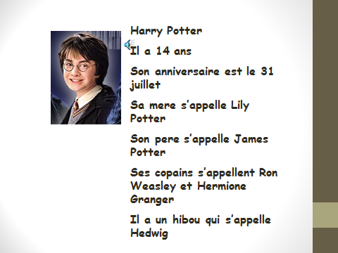
1.
2.
3.
4.
5.
6.
/6
*EXTRA-WRITE A SHORT PARAGRAPH ABOUT ONE OF THE OTHER CHARACTERS..
HOMEWORK 9
Find the following hidden words: cheveux, yeux, bleu, brun, noisette, blond, chatin, noir, roux, court, long

N C X W X U E V E H C A C O
I J S N R N I T A H C E F O
R D E E O L T O P N C Z E S
G N T I R E U X L E X H T U
M Y O T S E U E L Y N U R B
Y C O I L O X D D J H O E N
D G O B R L C I S P I G E Y
E N I U M T Q S G N Q N S N
F O O Z R N S P I J R G E E
O L L L E T I N N M Q W C G
W A A H B X D E M B I A S O
S T P N E J N I G J O A N R
O G R H O S E V S H E F O E
B G S G Y E T A R D D Z N D

/11
*EXTRA-PLEASE UNSCRAMBLE THE WORDS BELOW
1. chxeuev
2. xuey
3. lbeu
4. nurb
5. sntoetei
6. ldobn
7. aicnth
9. orxu=ROUX=RED(HAIR)
HOMEWORK 10
/10
*EXTRA-CAN YOU LABEL SOME OF THESE COUNTRIES ON THE MAP ?

HOMEWORK 11
WRITE 5 FACTS ABOUT ITALY IN ENGLISH…

1.
2.
3.
4.
5.

/5

*EXTRA-CHOOSE ANOTHER COUNTRY IN EUROPE AND WRITE A SIMILAR PARAGRPH IN FRENCH…
HOMEWORK 12
REVISION OF ALL THE ABOVE FOR END OF HALF-TERM TEST..

HOMEWORK
10

