Year 8 English Week 5

This week’s home learning is going to be slightly different from the previous weeks.

We are going to take a break from poetry and look at some writing skills. If we were in school, you’d normally have one writing lesson a week, so we need to refresh your knowledge/skills.

You will also be asked to watch a film! Yes, you read that correctly!

Your LSTs will recap the vocab that you have learned throughout the Year 8 and Year 7.

Answers to LSTs are at the end of the booklet.

Lesson 13

What is a review?

LST
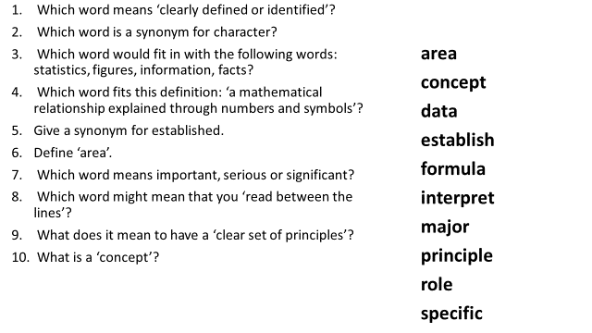
Teacher Instruction

KEY WORDS

Purpose: the reason something is done or created
Audience: the people who watch, read or listen to a book or film
Synonym: a word that has a similar meaning to another word
Protagonist: the main character in a book or film

Use this link to recap what a review is:

https://www.bbc.co.uk/bitesize/guides/zgr2xnb/revision/1

If you can’t click on the link, type ‘review writing and commentary’ into Google and select the first result.

Deliberate Practice

Read this review of ‘The Hunger Games’, then answer the questions that follow.

The Hunger Games: Catching Fire - The Odds Are Always in Your Favour

Ever seen it rain blood in a kids’ film before? How about a pensioner getting executed in front of his family? Or Lenny Kravitz being slapped in the face? The first Hunger Games caught flak because it dared to treat its YA audience like A’s – but things aren’t exactly looking any rosier in the sequel.
Following the unwritten lore of movie trilogies, the middle chapter of Katniss Everdeen’s sci-fi survival story is darker, moodier, meaner and, yes, better than Part 1. Outgrowing its Battle Royale meets Twilight meets The X Factor comparisons, Catching Fire expands Suzanne Collins’ novel beyond the confines of the arena to tackle some seriously brutal truths – plugging gaps and sowing seeds for a two-part finale that will have to work hard to match its grit.
And it’s Jennifer Lawrence’s performance that takes centre stage. Taking her post-Oscar fame publicly in her stride since she last picked up her bow, the 23-year-old actress has grown up as fast as her character. As mopey as the teenage love triangle almost gets, it’s the boys that do all the moping. Well on her way to becoming one of the greatest sci-fi heroines since Ripley, the avenger of District 12 is as undefined by her hidden vulnerability as she is by her inner strength; anchoring the series with an emotional realism that upstages everyone else in the film.
True, most of them are stuck in roles that haven’t developed much since we last met them. Peeta (Josh Hutcherson) is still an unlikeable wimp who cries every time he gets a paper cut, Gale (Liam Hemsworth) is still a gormless hunk who doesn’t do anything, and Donald Sutherland, Woody Harrelson and Elizabeth Banks are still hiding beneath candyfloss hair and panto outfits.
It’s all change behind the camera too, with new director Francis Lawrence (Constantine, I Am Legend) upping the menace both in and out of the arena. Marauding monkeys and axe-wielding gladiators might be pretty scary, but it’s nothing compared to an armed policeman beating a political dissident to death. In fact, Catching Fire often reflects real world horrors so impassively it’s easy to forget you’re watching a kids’ movie. Until you see Stanley Tucci’s hair, that is…
Yes, the Capitol still looks like the Emerald City, the big spinning thing in the arena comes straight out of Total Wipeout and the film’s cutting edge is dulled down and camped up whenever things get too gnarly. Some obvious concessions are made to appease the book’s devout fans too (At 146 minutes, it seems like they tried to fit every bloody page in), but it’s hard to see how anyone could be too disappointed with the incendiary results.
Then again, if the rousing finale of Catching Fire is anything to go by, Mockingjay is going to burn the house down…

Rating: *****

Write out quotations that show the following:

- The genre of the film.
- The name of the author of the original story/novel.
- 3 adjectives that describe a character/characters
- A rhetorical question.
- An allusion (referring to something else that is well known)
- 4 actors
- Alliteration

Challenge:
What is used right at the end of the text and why?

Learning Review

Write your own definition of a review.

Lesson 13 and 14

Can I review a film?

Before you start these lessons, look on the Eggbuckland Facebook page for the weekly ‘Litflix’ tv guide.

Choose one of the films from the post to watch. You are going to write a review on it. You might want to have a pen and paper handy while you watch.

Remember you can press the information button on your remote for some info on the film.

LST

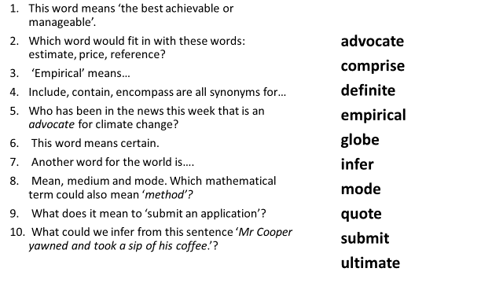

Deliberate Practice

Criteria:
- Include the strengths and weaknesses of the film
- Back up your opinions with evidence from the film
- Use an allusion
- Use humour
- Finish with a rating
LST Answers

Lesson 13

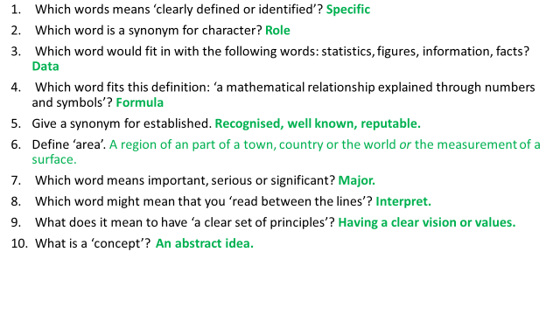Lesson 14 and 15

